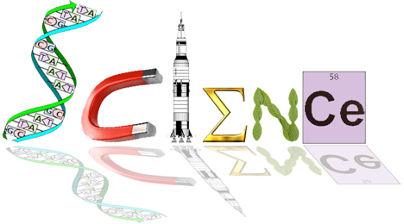


Human Biology Year 12
ATHBY 2021
Task 3: Homeostasis Test

Name: /65

Multiple Choice Section: 20 marks

Answer All Questions

1. Homeostasis is the process that keeps the internal environment constant.
As this is a complex process, models to explain how it works have been developed for different
aspects of the internal environment. One such model is the ‘stimulus-response feedback’ model.

Which of the following shows the components of the ‘stimulus-response feedback’ model
in the correct sequence?

a) stimulus, receptor, modulator, effector, response, feedback
b) stimulus, effector, modulator, receptor, response, feedback
c) stimulus, receptor, effector, modulator, response, feedback
d) stimulus, effector, receptor, modulator, response, feedback

2. In a stimulus response feedback loop model, the environmental signal that alerts us is best
described as the:

a) receptor
b) effector
c) response
d) stimulus

3. Receptors involved in regulating our body temperature are called

a) photoreceptors because light is associated with heat
b) chemoreceptors
c) thermoreceptors
d) mechanoreceptors

4. Antidiuretic hormone is involved with which homeostatic mechanism?

a) body fluid composition
b) body temperature
c) blood sugar
d) blood pressure

5. Dr Smith is giving a series of lectures on homeostatic mechanisms found in the body that control certain outcomes. He has received a note from one of his students with four possibilities regarding the hormone and the process by which glucose molecules are chemically combined in long chains to form glycogen molecules. Which one of the following options is correct?

a) insulin and glucogenesis
b) insulin and glycogenolysis
c) insulin and gluconeogenesis
d) insulin and glycogenesis

Question 6 refers to the graph below
6. Antidiuretic hormone is important in controlling water balance. The graph shows
changes in the concentration of antidiuretic hormone as plasma solute concentration changes.

The change in antidiuretic hormone in the blood plasma at 285 mOs/kg was due to

a) an increase in osmotic pressure in the cells.
b) a decrease in the solute concentration of the plasma.
c) an increased intake of water into the cells.
d) a decrease in blood pressure in the plasma.

7. Aldosterone is a hormone found in the adrenal medulla which acts on the liver to increase the amount of sodium. The statement would be correct if some or all of the words in bold were replaced with these words:

a) adrenal cortex and kidney
b) kidney and decrease
c) adrenal cortex, kidney, decrease and potassium
d) adrenal cortex, kidney and decrease

8. Which of the following statements concerning the control of blood gases is correct.
a) the carbon dioxide concentration produces the most immediate effect
b) the carotid and aortic bodies respond rapidly to the blood oxygen concentration.
c) hydrogen ion receptors are found only in the carotid artery
d) a more rapid rate of breathing is produced when the hydrogen ion concentration
increases.
9. Which of the below hormones can directly promote physiological responses to help LOWER blood glucose levels?

- Thyroid Regulating Hormone (TRH), Prolactin, Thyroxine
- Adrenaline, TSH, ACTH
- Cortisol, Calcitonin, Oestrogen
- Thyroxine, Cortisol, Adrenaline

10. After a meal of fish and chips with lots of salt which of the following would be true.
a) More sodium would be present in the urine
b) the secretion of aldosterone from the adrenal cortex would decrease.
c) the secretion of adrenalin from the adrenal cortex would decrease
d) both a and b above.
11. Negative feedback is where:
a) the stimulus affects the response to reduce the response.
b) the response affects the stimulus to reduce the stimulus
c) the stimulus affects the response to increase the stimulus.
d) the response is independent of the stimulus.
12. Homeostasis is
a) the maintenance of a constant internal environment for the efficient functioning of
cells.
b) the regulation of the composition of body fluids.
c) the maintenance of a stable internal environment for the optimal functioning of cells.
d) a regulated control of cell needs to provide for cellular respiration.
13. After a series of deep inhalations and exhalations (i.e. forced breathing) there is a period of reduced breathing rate because the:
a) The nitrogen concentration of the blood has increased
b) CO2 concentration of the blood has increased
c) CO2 concentration of the blood has decreased
d) O2 concentration of the blood has decreased.

14. After running hundreds of metres an athlete continues to breathe hard for some minutes because

a) the high level of oxygen in the blood stimulates the cardiovascular centre to
increase the breathing rate
b) the low level of bicarbonate ions in the blood stimulates receptors in the carotid and
aortic bodies to increase the breathing rate
c) the high level of carbon dioxide in the blood stimulates the receptors in the medulla
increase the breathing rate
d) he needs to lower down the body temperature because of the excess heat

15. Which of the following is correct about the role of insulin, it…
a) Stimulates cells to changes glucose to glycogen
b) Stimulates cells to changes glycogen to glucose
c) Slows down the oxidation of glucose by tissue cells
d) Slows down the change of fats and proteins to glucose.

16. If a drug completely destroyed the cells of a man’s pancreas, we would expect to
find a:
a) high concentration of glucose in his blood and in his urine
b) normal concentration of glucose in his blood and a high concentration in his urine
c) high concentration of glucose in his blood, but low concentration in his urine
d) low concentration of glucose in both blood and urine.

Question 17 refers to information below

Occasionally an individual is born without sweat glands. Such a person and a normal individual were placed in cool dry conditions and the skin and mouth temperatures recorded. The two persons were then placed in a moist hot environment and further recordings made. The results were as follows:
 | Skin temperature | Oral temperature | loss of H2O from  skin and lungs | Urine  Volume
Cool Dry Atmosphere  Person X  Person Y | 33.9oC  32.7oC | 36.9oC  36.9oC | 5g  5g | Not recorded  Not recorded
Hot moist atmosphere  Person X  Person Y | 40.0oC  37.6oC | 38.6oC  37.0oC | 22 gm  262 gm | 270 ml  10 ml

17. Select the correct statement from below.
a) person X was born with sweat glands
b) person Y was born without sweat glands
c) person X was born without sweat glands
d) person Y had more urine volume due to the presence of sweating.

18. When glucose molecules are chemically combined in long chains to form glycogen
the process is known as

a) gluconeogenesis
b) glycogenolysis
c) respiration
d) glycogenesis

19. Shivering is an effective means of combating cold because

- the rapid sequence of weak muscle contractions results in chemical energy being
converted to heat energy.
- it promotes piloerection which traps a layer of air next to the skin.
- it causes vasoconstriction, which greatly reduces heat loss from the skin.
d) it makes people engage in voluntary exercise and this warms the body.

20. Which of the following describe the mechanism responsible for preventing the lungs from over-inflating?

a) the stimulation of chemoreceptors in the respiratory centre.
b) the stimulation of stretch receptors in the lungs.
c) a build-up of carbon dioxide in the bloodstream.
d) the release of a hormone into the bloodstream

Short Answer: 35 marks

Answer All Questions

Refer to the diagram below to answer question 21.

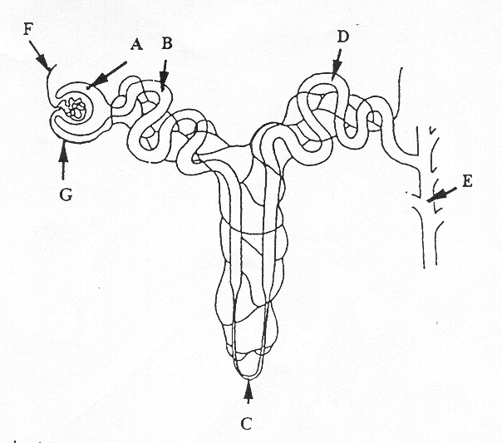

21. a) Name the two hormones that act on parts C and D. State where they are produced and describe their function . (6 marks)

Descriptions | Marks
D: Aldosterone | 1
D: Produced in Adrenal Cortex | 1
D: Increase salt reabsorbed into capillaries | 1
C: Parathyroid hormone | 1
C: Produced in parathyroid glands | 1
C: Parathyroid Increase Calcium reabsorption | 1

b) Explain how one of the hormones you identified in part is ‘a’ is regulated. (3 marks)
Descriptions | Marks
Aldosterone release is stimulated by a decrease in blood sodium levels,  An increase is ACTH  blood volume,  or blood pressure,  or an increase in blood potassium levels. | 3 (any 3)
Parathyroid hormone release is stimulated by a decrease in Ca²⁺ concentration in blood  Causing receptors on parathyroid cells to be activated  An increase in PTSH released by anterior pituitary | 3 (any 3)

22. The following questions refer to the graph below
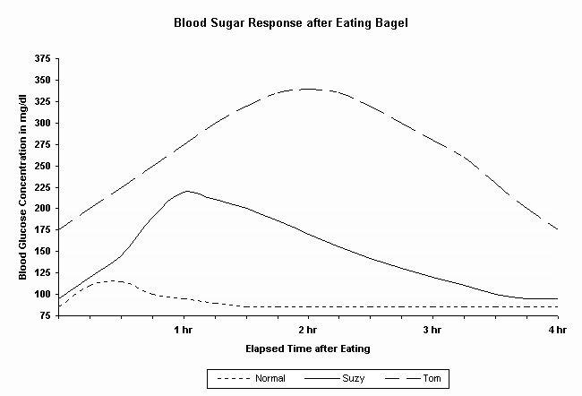

a) Describe what normally happens to blood glucose concentration following the consumption of a bagel. (2 mark)
Description | Mark
Initial increase in glucose concentration | 1
Followed by a return to normal concentrations after 2 hours | 1
Suzy and Tom both have abnormally high post-meal blood sugars. | 1

b) Which hormone would be secreted during this time? (1 mark)
Insulin
c) Describe how this hormone would achieve such an effect. (2 marks)
Description | Mark
Body cells are caused to increase their uptake of glucose/protein synthesis | 1
Liver and muscles increase glycogenesis | 1
Fat storage increased | 1
d) How long does it take for the “Normal” blood sugar levels to maintain homeostasis? (1 mark) 1.5 hours
e) Both Suzy and Tom’s blood glucose concentrations are much higher than normal.
Suggest why likely reasons for this is. (2 mark)
Reasons | Marks
Type 2 diabetes/NIDDM | 1
produce different amounts of insulin and their cells also differ in how well they can respond to that insulin | 1

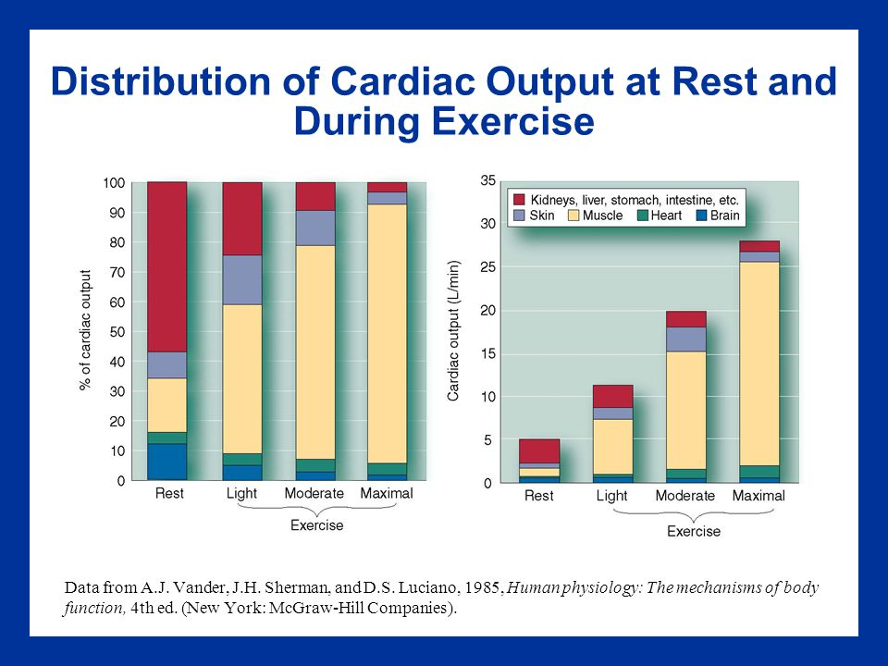

Examine the graph above:

23.a) What volume of blood flows to the gut and liver in 5 minutes when the body is at rest?
(1 mark)
3L/min x 5 minutes = 15 L

b) What is the percentage increase in blood flow to skeletal muscle between rest and
strenuous exercise? (1 mark)
(22L/1L) x 100 = 2200% increase

c) Explain how the changed blood flow to the various organs between rest and strenuous exercise is achieved (ie. how is the blood redirected)? (2 marks)
Explanations | Marks
Blood diverted away from non-essential areas such as gut | 1
CO increased | 1

d) Explain why there is increased blood flow to the skin during strenuous exercise. (1 mark)
Explanations | Marks
Medulla oblongata stimulated to vasodilate vessels in skin | 1
To increase heat loss via radiation | 1

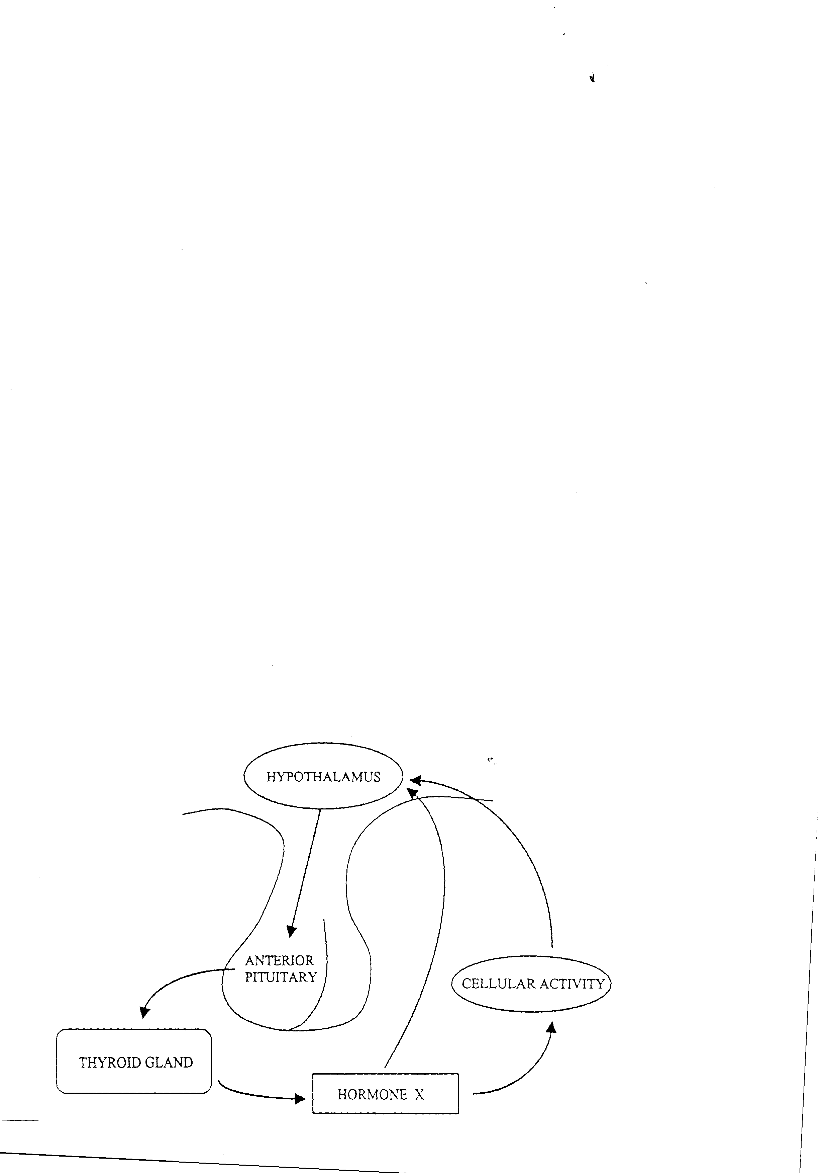
The diagram, below shows how the hypothalamus regulates the secretion of thyroid hormones. Use the diagram to help you complete the questions that follow.

24. a) Name two factors that stimulate the hypothalamus to initiate the control system. (2 marks)

Factor | Mark
Drop in core body temperature | 1
Decrease in blood thyroxine levels | 1

b) The hypothalamus responds by secreting TRH that acts on the anterior pituitary to cause it to secrete TSH (2 marks)

c) What is the name of hormone X released from the thyroid gland?

Thyroxine (1 mark)

d) List two ways the body responds to the release of hormone X. (2 marks)

Response | Mark
Increase cellular respiration | 1
Increase in O₂ consumption | 1
Increase heat production | 1

25. a) Explain why the cells of the body need to be maintained at a relatively steady
temperature of 37⁰C.
(2 marks)
Explanation | Mark
Optimal enzyme functional temperature | 1
Optimal temperature for cellular reactions | 1

b) List the ways in which the body tends to gain and lose heat (2 marks)

Gain | Mark | Loss | Mark
Increase BMR | 1 | Sweating (evaporation and convection) | 1
Vasoconstriction | 1 | Vasodilation (radiation) | 1
 |  | Reduce BMR | 1

c) What behavioural changes can we make to lower our core body temperature? (2 marks)

Gain | Mark | Loss | Mark
Heat from conscious behaviour | 1 | Increase SA | 1
Reduce SA | 1 | Loss from conscious behaviour | 1

Extended Answer Section: 10 marks

The PCAWA Tetrathlon is a 4 phase event requiring athletes to run 3 kilometres, swim as far as they can in 5 minutes, shoot 5 shots at a target using a laser pistol and ride a 2 km cross country. The event is always held in March and often temperatures are above 30$°$C. Competitors are encouraged to frequently drink water throughout the event.

With the aid of a fully labelled diagram explain the homeostatic process that would occur in the athlete’s bodies to ensure body fluids remain within the required tolerance limits to enable optimum function of the body cells.

Allocate 1 mark MAX each to stimulus and feedback
Allocate 2 marks MAX each to receptors, modulator, effector, and response

